Mission
- Goat Specialist
- Admin

- 5,081 posts
- Gender:Male
- Location:Monroe, MI
- Interests:Scholarly piracy, designing and creating haunted house rooms and props, movies, abstract thinking, abstruse thinking, obstructive thinking, ideating, random thinking, movies, cartoons, movies, movies scores, cycling, world peace and small furry dogs, movies, writing, drawing, personal skills training, gremlins and, of course, lest I forget, movies.
Posted January 9, 2013 · Report post
This is from "Extracts from the Diaries of Dr. John Covel, 1670-1679" in the book Early Voyages and Travels in the Levant, edited by J. Theodore Bent concerning clearing the ship for battle.
"It was pleasure to see the great alacrity and readinesse, I may say the eagernesse, of our Seamen in preparing for the dispute. All their Hamocks were down in a trice; their chests and lumber turn'd out into the boates, or stived [Editor's footnote 1: packed away, stuffed] by the main chains or elsewhere, out of the way. We had a clear ship in a very little while..." (Covel, p. 129)
I have some questions about this.
1. Wouldn't the hammocks have been below? I have images of them being hung on the orlop deck, although I understand that in a large ship they could be elsewhere.
2. Aren't the main chains on the exposed upper decks? They'd have to be to serve their purpose.
So why are the hammocks being taken from below and stowed on the main deck? Or am I missing something here?

Brit.Privateer
- Old Twillian
- Member

- 246 posts
- Gender:Male
- Location:North Carolina
- Interests:Atlantic World Maritime History during the Colonial Era. I specialize in early provincial era (1680-1740) and do quite a bit with pirate history.
Posted January 9, 2013 (edited) · Report post
On 1/9/2013 at 8:38 AM, Mission said:
This is from "Extracts from the Diaries of Dr. John Covel, 1670-1679" in the book Early Voyages and Travels in the Levant, edited by J. Theodore Bent concerning clearing the ship for battle.
"It was pleasure to see the great alacrity and readinesse, I may say the eagernesse, of our Seamen in preparing for the dispute. All their Hamocks were down in a trice; their chests and lumber turn'd out into the boates, or stived [Editor's footnote 1: packed away, stuffed] by the main chains or elsewhere, out of the way. We had a clear ship in a very little while..." (Covel, p. 129)
I have some questions about this.
1. Wouldn't the hammocks have been below? I have images of them being hung on the orlop deck, although I understand that in a large ship they could be elsewhere.
2. Aren't the main chains on the exposed upper decks? They'd have to be to serve their purpose.
So why are the hammocks being taken from below and stowed on the main deck? Or am I missing something here?
I think some context to the story would help here. What size of ship is this? Is it civilian or military?
When I read the quote, I don't get the impression that the bammocks are necessarily going up to the main deck. As for the chests, to me one potential reading of it is that they are being stacked and stowed on the part of the deck where the mainmast is (in addition to where the boats are and other places) and not actually on the external part of the ship near the chain plates.
Can't say much more until I get some context, but based on what I see, I am guessing this is a civilian ship.
Edited January 9, 2013 by Brit.Privateer

Mission
- Goat Specialist
- Admin

- 5,081 posts
- Gender:Male
- Location:Monroe, MI
- Interests:Scholarly piracy, designing and creating haunted house rooms and props, movies, abstract thinking, abstruse thinking, obstructive thinking, ideating, random thinking, movies, cartoons, movies, movies scores, cycling, world peace and small furry dogs, movies, writing, drawing, personal skills training, gremlins and, of course, lest I forget, movies.
Posted January 9, 2013 · Report post
I see what you mean. He is probably talking about stowing the chests and lumber and not necessarily the hammocks. However, he appears to be specific on these things being placed in boats (I take this to mean the small craft kept for going from ship to shore) or near the main chains. This is why I thought he must be referring to the chain plates. I've seen draughts of naval ships showing chain plates on the deck.
I am really trying to find evidence of the orlop deck being cleared (since I want to say that they did so in preparation for it becoming the surgery and waiting area for wounded.) This is why I was focusing on the hammocks, which I have seen in images as being on the orlop where the surgery was usually placed.
As for details of the ship, Covel was aboard the merchant ship London Merchant, captained by John Hill. It was part of a convoy of seven merchant ships headed for the Levant. I didn't find that Covel gave any more detail than that.

Brit.Privateer
- Old Twillian
- Member

- 246 posts
- Gender:Male
- Location:North Carolina
- Interests:Atlantic World Maritime History during the Colonial Era. I specialize in early provincial era (1680-1740) and do quite a bit with pirate history.
Posted January 9, 2013 (edited) · Report post
I just went and looked over the diary, briefly. The "London Merchant" appears to be a civilian vessel (or at least the lists of navy vessels don't show such a vessel present in the 1670s - except a hired vessel in a very brief service to the Navy four years earlier, listed to have been 87' length of keel by 28' 9" breadth, 382 tons burthen, crew compliment of 180, 48 guns http://threedecks.or...w_ship&id=12103 ).
Maybe I am reading what you are saying wrong, but chain plates are usually bolted outside onto the hull and not on a deck. If they were to correspond to a deck, it would be a main or gun deck on larger vessels (which the London Merchant would be), and on small ones (we are talking less than 100 tons), it would end up being the orlop. It just sounds like the hammocks were being stowed down below, probably into the hold. I've read several other descriptions from this period concerning getting ready for action, and they often note simply sending chests and hammocks below, especially since hammock netting wasn't around yet (which can be attributed to the hammock only being largely adopted in the second half of the seventeenth century). Since it seems important enough to note that the hammocks had to be struck down for action, it sounds like they are verifying there was a gun deck (you would need one if there are 48 guns). Since it's a merchant vessel, the deck was probably crowded with more than just guns. In a merchant vessel, you tried to get all the room you can get for cargo (ergo profit). So, the crew more than likely stayed there (if there wasn't enough room in the forecastle, if there was a forecastle of note). There might of been some compartments for passengers there, and some bulkheads for assisting in the storage of some cargo as well. On a merchant vessel, it wasn't crucial for all the guns to be in a nice, uniterrupted line. This might explain why some (not all, as noted in the text itself) got stowed amidships near the main chains. If Cowel was trying to say it was unusal to stow some chests in this area, it is understandable since navy vessels would not do this for the purpose of allowing as clean a sweep fore and aft on the gun deck.
Hopefully that clears up some things.
Edited January 9, 2013 by Brit.Privateer

Mission
- Goat Specialist
- Admin

- 5,081 posts
- Gender:Male
- Location:Monroe, MI
- Interests:Scholarly piracy, designing and creating haunted house rooms and props, movies, abstract thinking, abstruse thinking, obstructive thinking, ideating, random thinking, movies, cartoons, movies, movies scores, cycling, world peace and small furry dogs, movies, writing, drawing, personal skills training, gremlins and, of course, lest I forget, movies.
Posted January 9, 2013 · Report post
On 1/9/2013 at 10:39 AM, Brit.Privateer said:
I've read several other descriptions from this period concerning getting ready for action, and they often note simply sending chests and hammocks below...
Do you have references? I might be able to use them.
I agreed the hammocks would be stowed below after reading your first post. I can't imagine them tucking the chests in the chain plates on the sides of the ship. (Lumber, possibly.) I have seen chain plates shown on the deck in some draughts and Covel does say "by the chain plates" which suggests to me setting them on a flat surface. (I may be reading too much into it here, but we're getting too far into the picayune details for what I need. I just wanted to verify that it didn't suggest that the hammocks went on the main deck and that the orlop was cleared.)

Coastie04
- Dread Pyrate
- 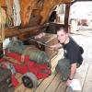
- Member

- 1,008 posts
- Gender:Male
- Location:Juneau, AK
- Interests:Nautical history, sailing (especially tall ships and my own 'Sanctioned Mistress'), shooting (of all eras and calibers), and homebrewing.
Posted January 9, 2013 · Report post
Reading the exerpt, I had a bit different take on the hammocks being "down in a trice." Is it possible that due to the time of day, or it being a merchant ship, that the hammocks were hanging from the overhead and they were taken down from their 'sleeping positions' in order to help clear the deck? Getting large swaths of canvas out of the way instead of hanging all over the gun or orlop deck would definitely be helping to clear the deck. As for the furniture, during combat the small boats were often towed astern in order to try and prevent damage to them. Thus, it serves two purposes to put furniture (especially anything nice) in the boats: to prevent damage to them and to get them out of the way. As far as stowing the rest (presumably what would not fit) near the main chains, I can think of two reasons. One, it might help the trim (generally weight low and in the center of the boat is good), though it's probably fairly negligible on a vessel carrying cargo. The other reason, as mentioned above, might just be to get it out of the way in one area. By the main chains would generally be one of the widest parts of a ship, so it might just be the most convenient place to store the furniture that was most out of the way.
Coastie

Mission
- Goat Specialist
- Admin

- 5,081 posts
- Gender:Male
- Location:Monroe, MI
- Interests:Scholarly piracy, designing and creating haunted house rooms and props, movies, abstract thinking, abstruse thinking, obstructive thinking, ideating, random thinking, movies, cartoons, movies, movies scores, cycling, world peace and small furry dogs, movies, writing, drawing, personal skills training, gremlins and, of course, lest I forget, movies.
Posted January 9, 2013 · Report post
Somewhere I read that men might be sleeping at any time of day based on the watch schedule. (I have no idea whether this is true or not, nor do I recall where I read it.) I always assumed the hammocks would be left hanging if there was no reason to take them down. I figured that when they cleared the decks for an engagement, the hammocks would come down and stowed out of the way so the ship was ready for fighting and dealing with wounded. There would be no one abed (outside of the sick and wounded) during a conflict.
I have also read that the hammocks were sometimes hung in the gun deck (which I believe is what Brit.Privateer is talking about in his second post.) They would definitely need to be taken down during action as he mentioned.
To add to the confusion of this discussion, the orlop deck sometimes served as a gun deck if it was above the waterline. Pirates were known to cut gun ports for the orlop so they could make their ship more formidable. In fact, all of the gun decks could be, and sometimes were, referred to as orlop decks. I have also seen reference to the surgeon being put into the cockpit which was described as being in "the hold." So part of the issue becomes the terminology soup of the time.
My confusion was originally over why the hammocks would be stowed above, which I have agreed wasn't what Covel was saying. (Actually, I really just wanted someone else to read through that and verify what I thought - the hammocks would be stowed on the deck where they were located when the deck was cleared for the surgeon. I am writing about the surgeon, after all. )

Brit.Privateer
- Old Twillian
- Member

- 246 posts
- Gender:Male
- Location:North Carolina
- Interests:Atlantic World Maritime History during the Colonial Era. I specialize in early provincial era (1680-1740) and do quite a bit with pirate history.
Posted January 9, 2013 · Report post
On 1/9/2013 at 4:05 PM, Mission said:
Somewhere I read that men might be sleeping at any time of day based on the watch schedule. (I have no idea whether this is true or not, nor do I recall where I read it.) I always assumed the hammocks would be left hanging if there was no reason to take them down. I figured that when they cleared the decks for an engagement, the hammocks would come down and stowed out of the way so the ship was ready for fighting and dealing with wounded. There would be no one abed (outside of the sick and wounded) during a conflict.
I have also read that the hammocks were sometimes hung in the gun deck (which I believe is what Brit.Privateer is talking about in his second post.) They would definitely need to be taken down during action as he mentioned.
To add to the confusion of this discussion, the orlop deck sometimes served as a gun deck if it was above the waterline. Pirates were known to cut gun ports for the orlop so they could make their ship more formidable. In fact, all of the gun decks could be, and sometimes were, referred to as orlop decks. I have also seen reference to the surgeon being put into the cockpit which was described as being in "the hold." So part of the issue becomes the terminology soup of the time.
My confusion was originally over why the hammocks would be stowed above, which I have agreed wasn't what Covel was saying. (Actually, I really just wanted someone else to read through that and verify what I thought - the hammocks would be stowed on the deck where they were located when the deck was cleared for the surgeon. I am writing about the surgeon, after all. )
I think the question of clearing for battle depends on what service and what time period we are talking about. As you spotted, with Navy versus civilian, it is essencial to keep a ship clear for action at any time, while a civilian vessel does not have that.
As for sleeping during the day, when sailors were not on duty, they would take naps when they could. Quite a few watch systems set things up so that the average sailor would get 4 hours of sleep per night (on a normal night that didn't require everyone to do something on deck). While it is possible for some people to operate on four hours a day, some can't - so they tried to sneek in naps wherever the could. But napping/sleeping didn't require a hammock. Before hammocks, people slept on the decks and sometimes on top of large sea chests.
Now, back to those hammocks. One thing I am going to have to do is look up when hammock netting came around and the whole routine of stowing away hammocks. It might help with all this. One thing that sticks in my mind is that the advantage of not having hammocks stowed but not hung up is that with the hammocks down, sailors could at least access them for the bedding in it and odd items they may keep in there (like spare clothing).
As for the orlop deck references you made (the guns on the orlop deck, a variety of decks being called orlop), could I see some sources on that?

Dread Pyrate Greyhound
- Plunderer
- Member

- 451 posts
- Gender:Male
- Location:Ohio
- Interests:Golden Age of Pyracy, Age of Sailing ships (spacifically 1600-1730) Vintage pirate Legos, weaponry in usage during the Age of Pyrates, Fuedal Japan
Posted January 9, 2013 · Report post
On warships, you had a large detachment of crew, gunners marines etc, the hammocks would have to accomodate them all, and even if they were on the orlop deck, you'd want to stow them away, to clear a path for crew such as carpenters patching damage, powder monkeys fetching munitions, and wounded crew being carried into the sick bay.

Mission
- Goat Specialist
- Admin

- 5,081 posts
- Gender:Male
- Location:Monroe, MI
- Interests:Scholarly piracy, designing and creating haunted house rooms and props, movies, abstract thinking, abstruse thinking, obstructive thinking, ideating, random thinking, movies, cartoons, movies, movies scores, cycling, world peace and small furry dogs, movies, writing, drawing, personal skills training, gremlins and, of course, lest I forget, movies.
Posted January 10, 2013 · Report post
On 1/9/2013 at 8:33 PM, Brit.Privateer said:
Now, back to those hammocks. One thing I am going to have to do is look up when hammock netting came around and the whole routine of stowing away hammocks. It might help with all this. One thing that sticks in my mind is that the advantage of not having hammocks stowed but not hung up is that with the hammocks down, sailors could at least access them for the bedding in it and odd items they may keep in there (like spare clothing).
Most interesting! I look forward to hearing more.
On 1/9/2013 at 8:33 PM, Brit.Privateer said:
As for the orlop deck references you made (the guns on the orlop deck, a variety of decks being called orlop), could I see some sources on that?
That would be telling. Actually, my evidence for this will be in the second half of the Surgeon's Quarters article which should be posted on my web page in the next week or so. I am working feverishly on it now that the Journal for the Fort Taylor Pyrate Invasion is finished.

Silver
- Plunderer
- Member

- 347 posts
- Gender:Male
- Location:Virginia Beach, Virginia
- Interests:Maritime history
Posted January 10, 2013 · Report post
just to kick this in, powder chests were built to look like sea chests and the chains would be a place that boarder would attemp to come aboard. a dr. may not know this.

Mission
- Goat Specialist
- Admin

- 5,081 posts
- Gender:Male
- Location:Monroe, MI
- Interests:Scholarly piracy, designing and creating haunted house rooms and props, movies, abstract thinking, abstruse thinking, obstructive thinking, ideating, random thinking, movies, cartoons, movies, movies scores, cycling, world peace and small furry dogs, movies, writing, drawing, personal skills training, gremlins and, of course, lest I forget, movies.
Posted January 13, 2013 · Report post
I thought this was interesting regarding hammocks. It's from Boteler's Dialogues, published in 1634.
"The over-high charging of ships also with cage-works is the main cause of most of the ill qualities, making them to be extreme leeward ships, to sink keep in the water, and to be apt to be over-set. And though the common seaman liketh it well enough, as coveting store of cabins, yet are these cabins no better than nasty holes, which breed sickness, and in a fight are very dangerous, as causing much spoil with their splinters; so that all long voyages, especially to the southwards, the lodging of the common
__
men in hammocks is far more wholesome and preferable.” (Boteler, p. 257-8)

Brit.Privateer
- Old Twillian
- Member

- 246 posts
- Gender:Male
- Location:North Carolina
- Interests:Atlantic World Maritime History during the Colonial Era. I specialize in early provincial era (1680-1740) and do quite a bit with pirate history.
Posted January 13, 2013 · Report post
On 1/13/2013 at 10:20 AM, Mission said:
I thought this was interesting regarding hammocks. It's from Boteler's Dialogues, published in 1634.
"The over-high charging of ships also with cage-works is the main cause of most of the ill qualities, making them to be extreme leeward ships, to sink keep in the water, and to be apt to be over-set. And though the common seaman liketh it well enough, as coveting store of cabins, yet are these cabins no better than nasty holes, which breed sickness, and in a fight are very dangerous, as causing much spoil with their splinters; so that all long voyages, especially to the southwards, the lodging of the common
__
men in hammocks is far more wholesome and preferable.” (Boteler, p. 257-8)
It sounds like he is more referring to the tendency of 16th and early 17th century ships to build additional cabins on the deck of a vessel, though he could also be referring to the use of cabins in general as being unhealthy. I remember reading about the Spanish tendency towards building cabins high up in the book Spain's Men of the Sea. The biggest problem is overburdening the ship and making it top heavy to the point of capsizing.
Okay, now for the development of hammock netting. According to Lavery's Arming and Fitting of English Men of War (which actually quotes the above from Boteler's Dialogues), on pg 245, it says that some of the first solid documentation for them came in the 1740s, though it is possible some small use of them existed in the 1730s. They were in gereal use on British naval ships by the 1750s. The greater purpose for them was to develop protective barricades for the men, even though they were not good as closed wooden railings as typical in the waist (but better than the experiments with "arming cloth"). It says that the hammocks were typically stowed under the quarterdeck otherwise. It doesn't elaborate how far that tradition went back.
As for the naval tendency for rolling up and stowing away hammocks, it doesn't have much detail. It says that it was common procedure for sailors to roll up and pack their hammocks when a sailor was on duty. Beyond that, it doesn't say if and when they stowed them besides during battle. The general idea I get is that the navy tended to wards keeping a ship relatively ready for combat during regular duty hours, which by the mid eighteenth century meant stowing the hammocks in netting when not sleeping in it. As for before 1740, kind of unclear, but we can at least say the navy tended towards not hanging them up during the day.

Coastie04
- Dread Pyrate
- Member

- 1,008 posts
- Gender:Male
- Location:Juneau, AK
- Interests:Nautical history, sailing (especially tall ships and my own 'Sanctioned Mistress'), shooting (of all eras and calibers), and homebrewing.
Posted January 14, 2013 · Report post
On 1/13/2013 at 10:20 AM, Mission said:
"The over-high charging of ships also with cage-works is the main cause of most of the ill qualities, making them to be extreme leeward ships, to sink keep in the water, and to be apt to be over-set
In addition to the stability issue that Brit. Privateer brought up caused by building up on ships, it also made them worse sailing vessels. As any racing sailor can tell you, a lower overall hull profile is faster (and thus a better and safer vessel). The more 'sail area' you have due to the hull and superstructure, the more you get pushed strait to leeward. The actual sails redirect the leeward force into mostly forward force (or just about whichever direction you want it to push depending on your maneuvering desires-but usually forward). The hull, on the other hand, cannot be trimmed in this respect. Therefore, an otherwise identical boat with a higher hull/superstructure will not be able to make as much way to windward as the lower profile one. There are definitely reasons to have high bulwarks on boats (cargo capacity, gun decks, seaworthiness in larger seas, comfort, etc.), but it does not make them better sailors. Many racing sailboats get their best speed when the leeward rail is just skimming the surface of the water. There is little to no cabintop/superstructure to them, and when they do have a little cabin top, it is usually covered by the hull when sailing in heavy weather.
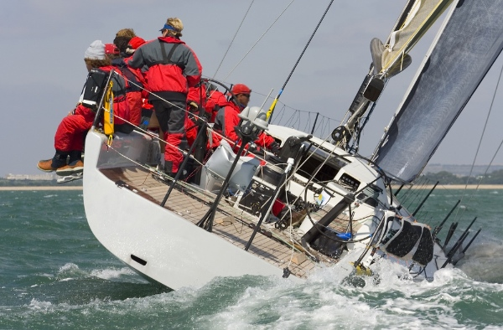
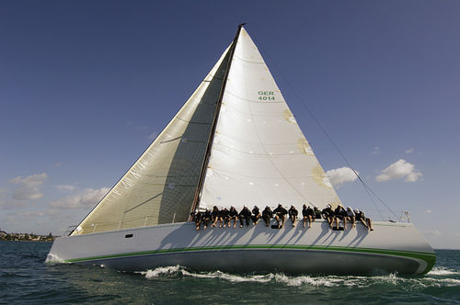

You can also see this in the progression of ship design. Most clipper ships had flush, or nearly flush decks compared to the high fo'c's'le and poop deck ships of the previous centuries.
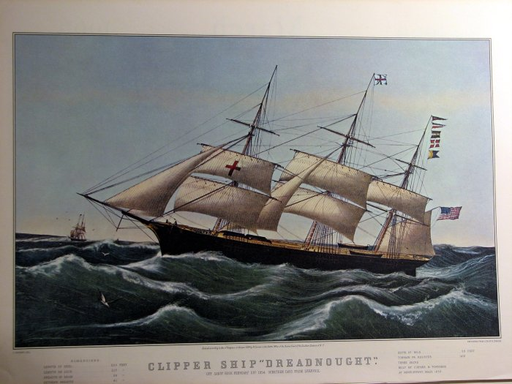
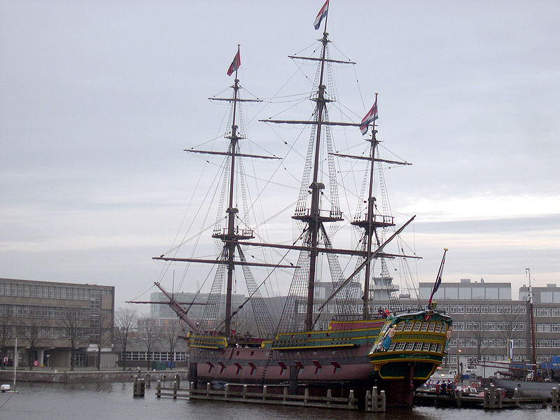
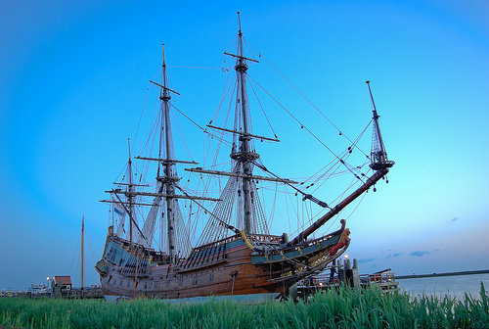
Coastie

